3rd Asian Conference on Institutional and Action Research
(ACIAR 2019)
November 28-30, 2019
Cagayan de Oro City, Philippines

Conference Theme:
“From Institutional and Action Research to Publications of Best Practices”

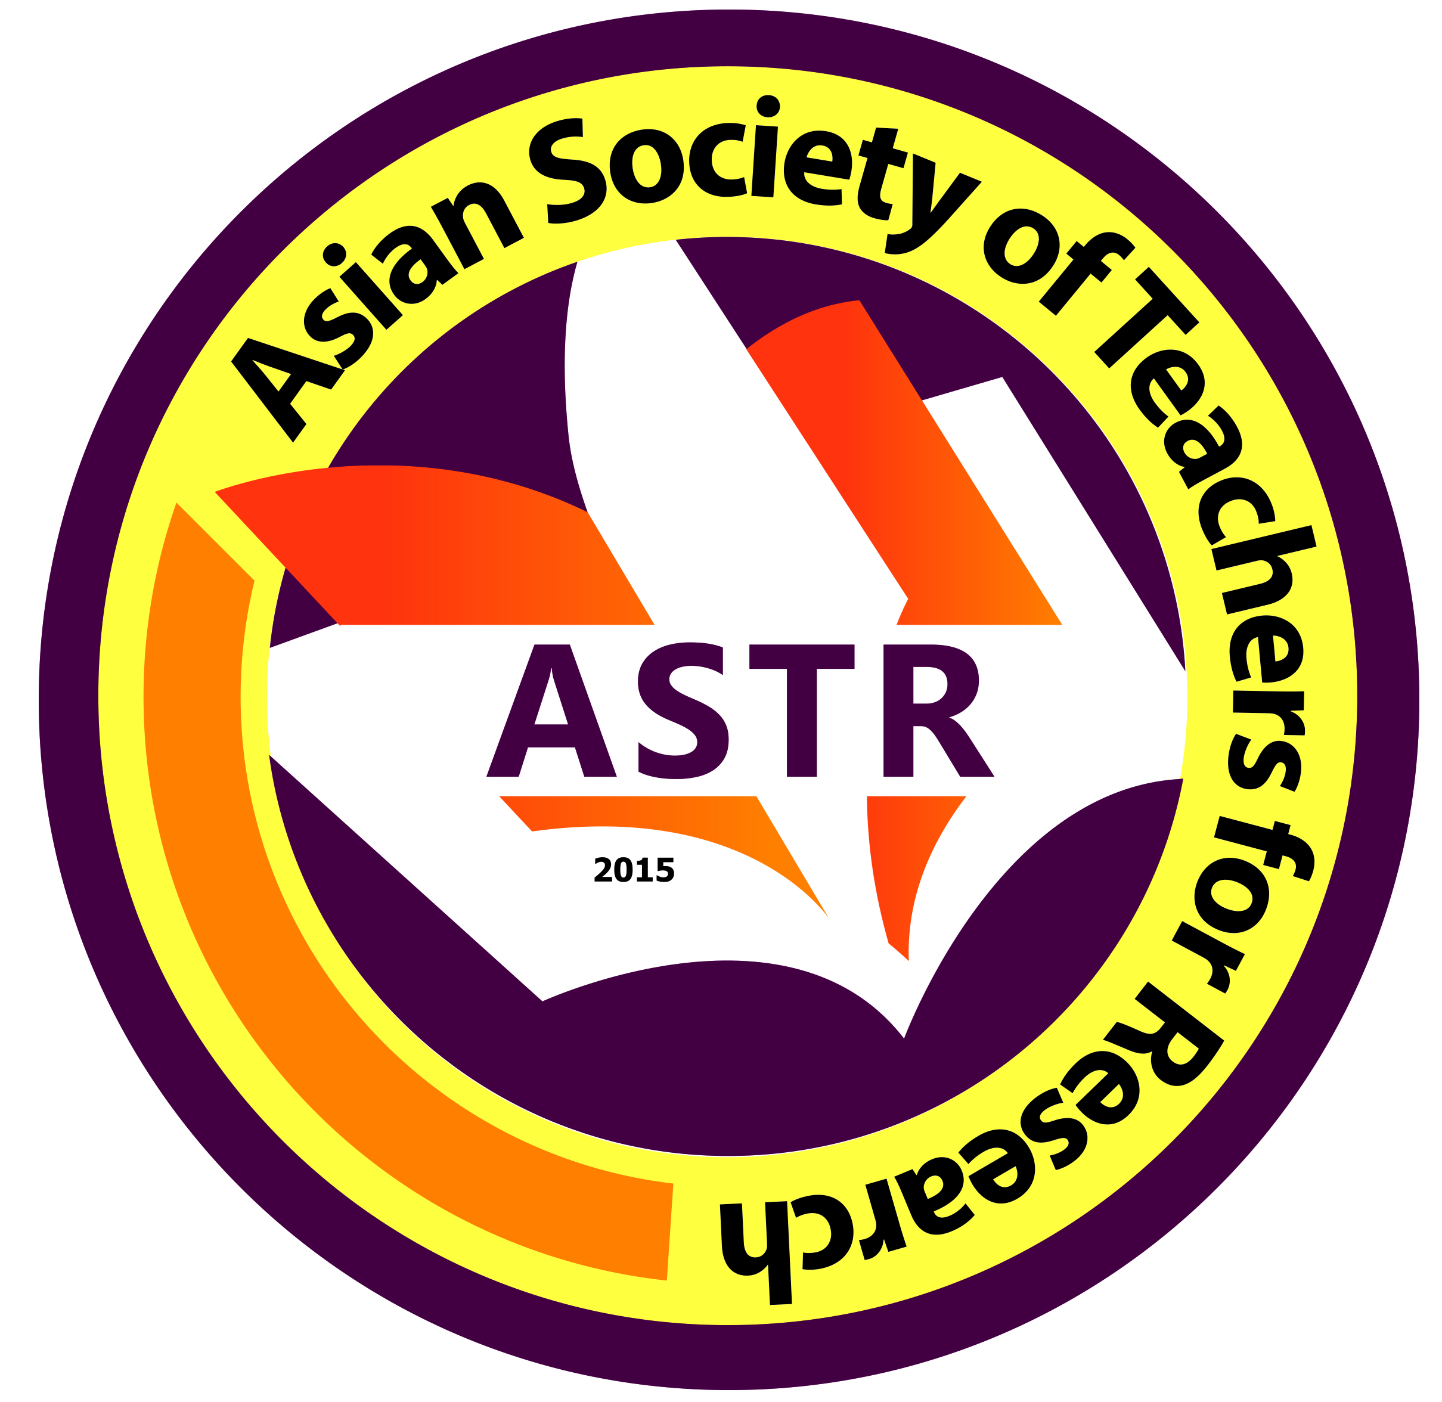
OBSERVER REGISTRATION FORM

Date Filed:

First Name:
Middle Name:
Last Name:
Email Address:
Mobile No. (begin with country code):
ORCID No (register at www.orcid.org):
Field(s) of Expertise:
Organization/School/University/Affiliation:
Address of Organization/School/University/Affiliation:

*Please attached the following documents together with this filled-out form:
(a) formal ID Photo;
(b) Updated Curriculum Vitae;
(c) deposit slip

